How to sell an ad:
- Be determined. Selling an ad isn’t hard if you put some thought and effort into it. Think of people you know. Talk to your parents and other adults. Look at who purchased ads in past programs. Everywhere you go, every business you visit, ask them to buy an ad: your dentist, the restaurant, your voice teacher, etc.
- Be confident. Wear CCHS apparel. Tell them what an awesome theatre program we have and that they can help support it. Point out (it’s on the Sponsorship Form) how many people will see their ad and the expenses their ad will help pay for.
- Be diligent. Fill out the Sponsorship Form completely and get full payment right then and there. The Advertising Coordinator will follow up with the business to get artwork and other information. Please make sure the contact info is complete and legible.
- Be prompt. Take the payment to the office and get a receipt, then turn that receipt with the Sponsorship Form to Mr. Hamilton,Mrs. Atkinson, or the basket by Wednesday, October 8th Remember the office won’t take payments after 2 pm.
- Be courteous. Thank the business for their support. You might want to send them a program with a thank you note after the show. These kinds of niceties pay big dividends when you approach them next year.

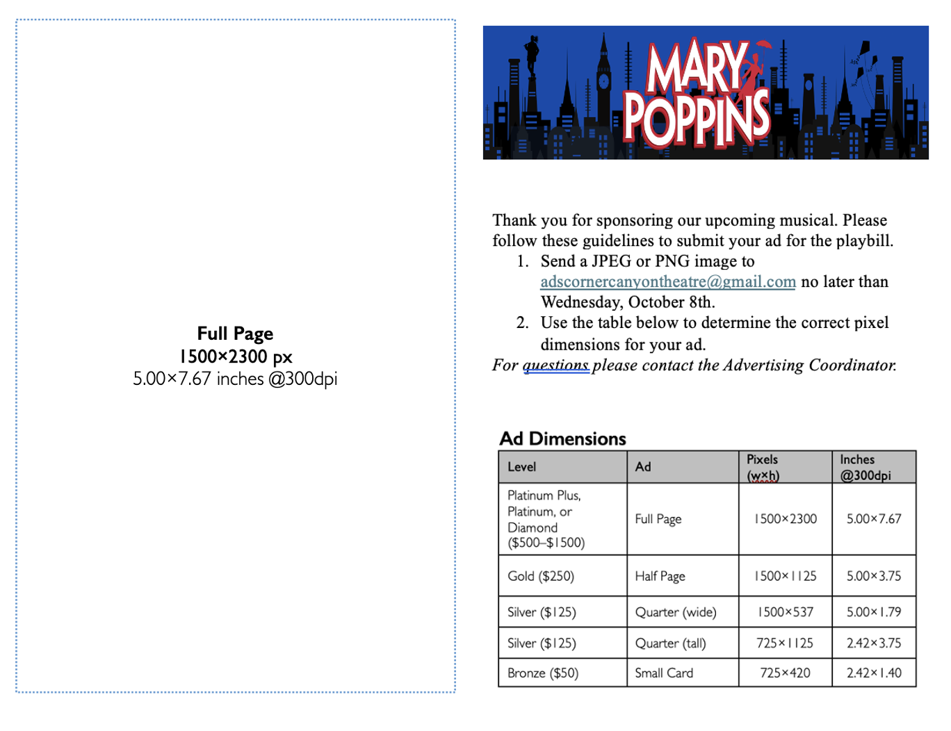
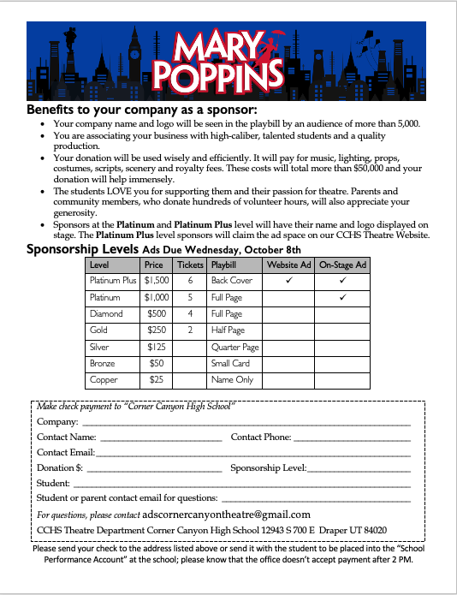
Sponsorship Form
Use this to explain the sponsorship levels and the benefits to the business and to our theatre program. Return the form with payment by Friday October 13th.

Business Handout
Use this to show what the ads look like at their actual sizes. Please leave this with the business so they know what size their ad image needs to be, and where to send it. Circle the ad size they purchased to help remind them.

